Name

Mathematics Extension 1 Year 12
Further Calculus Skills

Book 1 | Further derivatives of functions  Techniques of integration | Version: 261002  Feedback:  https://MrDingMaths.com
Contents
Syllabus Content 2
Learning Intention 3

Syllabus Content
MA5-EQU-C-01 solves linear equations of up to 3 steps, limited to one algebraic fraction
Solve linear equations involving up to 3 steps
- Solve linear equations using algebraic techniques involving up to 3 steps
- Solve linear equations with pronumerals on both sides of the equation
- Solve linear equations involving grouping symbols
- Verify solutions using substitution

Equations with $x$ on Both Sides

- Equations with $x$ on Both Sides
If an equation has $x$ on both sides, we first want $x$ terms on only one side.
We do this by adding or subtracting a multiple of $x$ from both sides.
- We should add or subtract so that the resulting coefficient of $x$ is positive.

- Identify operation to eliminate $x$ on one side
$$5x+1=3x+7$$  $$-3x -3x$$  $2x+1=7$ | $$3x+1=5x+7$$  $$-3x -3x$$  $1=2x+7$ | $$1-5x=3x+7$$  $$+5x +5x$$  $1=8x+7$
Identify the multiple of $x$ to add or subtract.
- $2x+5=x+8$ | - $x+8=2x+5$ | - $8-x=2x+5$
- $8-x=2x-5$ | - $x+8=2x-5$ | - $2x+8=4x+5$
- $2x+8=5-4x$ | - $8-2x=5-4x$ | - $8-2x=-4x+5$

- Key Ideas
- When $x$ appears on both sides, we want to change the equation so that all $x$ terms are on …………… side.
- We do this by adding or subtracting a ………………… of $x$ from both sides.
- We want to keep the coefficient ………………… so the solving is easier.

- Solving Equations with $x$ on Both Sides
- Add or subtract a multiple of $x$ so $x$ terms are only on one side.
Try to make the coefficient of $x$ positive, if possible.
- Solve for $x.$

- Example Solve equations with pronumerals on both sides
$$2x+5=x+8$$  $-x -x$  $x+5=8$  $-5 -5$  $x=3$ | $$2x+7=5x+1$$  $-2x -2x$  $7=3x+1$  $-1 -1$  $6=3x$  $÷3 ÷3$  $2=x$

- Guided Practice
- $3x+2=x+6$ | - $2x+12=5x$
- $5x-3=2x+7$ | - $7x=12-5x$
- $5x+12=16+4x$ | - $6x=27-3x$

Foundation
- Fill in the missing operation.
$$4x-2=3x+3$$  …… ……  $$x-2=3$$  $$-3x$$ | $$2+4x=5x+1$$  …… ……  $$2=x+1$$  $$-4x$$

- Complete the following.
$$5x+3=2x+8$$  $$-2x -2x$$  ……… $=$ ………  $$3x+3=8$$ | $$9x+5=12x+21$$  $$-9x -9x$$  ……… $=$ ………  $$5=3x+21$$
$$2x+9=5-2x$$  $$+2x +2x$$  ……… $=$ ………  $$4x+9=5$$ | $$15x+12=13-7x$$  $$+7x +7x$$  ……… $=$ ………  $$22x+12=13$$
$7x=3x+4$  …… $=$ 4  $$4x$$ | $9x+2=5x+10$  ……… $= 10$  $$4x$$
$4x+2=8-2x$  ……… $=8$  $$6x$$ | $2-3x=5x+4$  $2 =$…………  $$8x+4$$

- Consider the balance model.
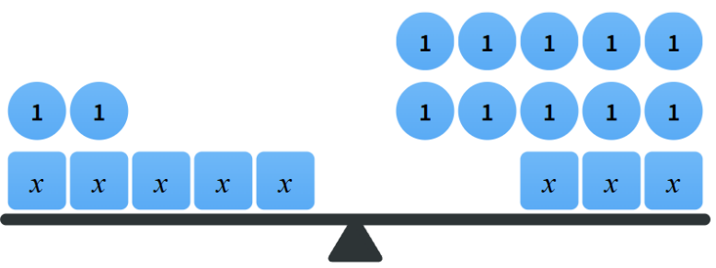
  - What equation does this show?
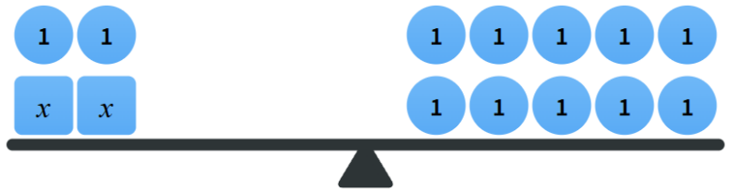
$$5x+2=3x+10$$
  - $3x$ can be subtracted from each side.
What equation is shown now?

$$2x+2=10$$
  - Solve the equation you wrote for part b.

$$x=4$$
  - Verify your solution by substituting into LHS and RHS of the original equation.
LHS = $5x+2=22$
RHS = $3x+10=22$

- Solve these equations.
$$3x=x+6$$  …… ……  $$2x=6$$  …… ……  $x=$ ………  $$x=3$$ | $$2x+1=x+4$$  …… ……  …… $=$ ………  …… ……  $x=$ ………  $$x=3$$
$$x+2=5x$$  …… ……  …… $=4x$  …… ……  …… $=x$  $$x=\frac{1}{2}$$ | $$x-4=3x$$  …… ……  …… $=$ $2x$  …… ……  …… $=x$  $$x=-2$$
$5x+6=x+10$  …… ……  …… $=$ ………  …… ……  …… $=$ ………  …… ……  $x=$ ………  $$x=1$$ | $4x+8=6x-2$  …… ……  $8 =$ ………  …… ……  …… $=$ ………  …… ……  …… $=$ $x$  $$x=5$$

- Solve these equations.
- $7y=5y+9$  ……… ………  ………… $=$ …………  ……… ………  ……… $=$ ………  $$y=4.5$$ | - $3k=k+8$  ……… ………  ………… $=$ …………  ……… ………  ……… $=$ ………  $$k=4$$
- $3x+6=2x+9$  ……… ………  ………… $=$ …………  ……… ………  ……… $=$ ………  $$x=3$$ | - $10k=12-8k$  ……… ………  ………… $=$ …………  ……… ………  ……… $=$ ………  $$k=\frac{2}{3}$$
- $3a+6=a+18$  $$a=6$$ | - $6n+5=2n+17$  $$n=3$$
- $5x-3=2x+6$  $$x=3$$ | - $3d-6=d-4$  $$d=1$$
- $3m+5=-m+26$  $$m=\frac{21}{4}$$ | - $4x+3=-2x+7$  $$x=\frac{2}{3}$$

Development
- Ashley and Amelia are solving the equation $8x+3=2x+21$
I’m going to subtract $2x$ from both sides first


I’m going to subtract $8x$ from both sides first

Solve the equation using both methods.
$$6x+3=21$$  $$6x=18$$  $$x=3$$ | $$3=-6x+21$$  $$-18=-6x$$  $$3=x$$
Which method do you prefer?

Ashley’s method avoids negative coefficients of $x$.


- Emma and Harriet are solving the equation $10-3t=2+5t$
I'm going to subtract $5t$ from both sides.
I'm going to add $3t$ to both sides.

Whose strategy is most sensible? Explain why

The second method avoids negative coefficients of $x$.
Solve the equation using both methods.
$$10-8t=2$$  $$-8t=-8$$  $$t=1$$ | $$10=2+8t$$  $$8=8t$$  $$t=1$$

- Solve these equations.
- $x+5=3x+3$  $$x=1$$ | - $-5+x=-3+3x$  $$x=-1$$ | - $3-3x=5-x$  $$x=-1$$
- $x-5=3x+3$  $$x=-4$$ | - $5-x=3-3x$  $$x=-1$$ | - $3-3x=5+x$  $$x=-\frac{1}{2}$$
- $x-5=3x-3$  $$x=-1$$ | - $5+x=3-3x$  $$x=-\frac{1}{2}$$ | - $3+x=5-3x$  $$x=\frac{1}{2}$$
- $x-5=-3+3x$  $$x=-1$$ | - $5-x=-3-3x$  $$x=-4$$ | - $3-x=5+3x$  $$x=-\frac{1}{2}$$

- Complete the following.
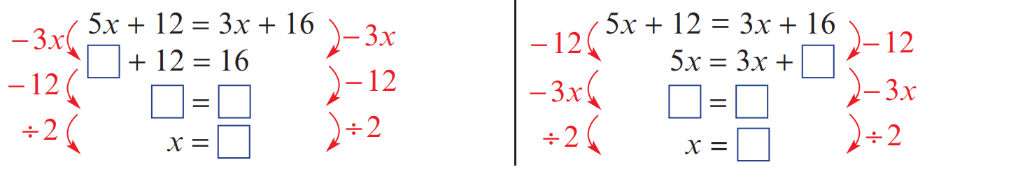  $$x=2$$ | $$x=2$$

The two equations above are the same. Which method do you prefer?

- Read the examples carefully and answer the questions.
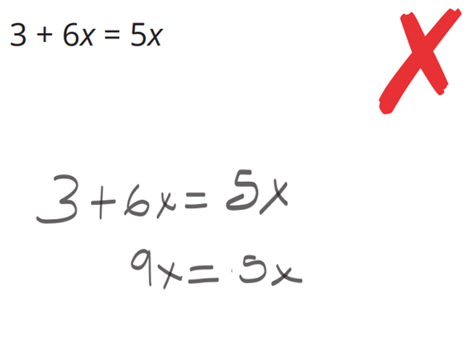  Jackson’s work: | Which terms did Jackson incorrectly combine to get $9x$?  $3+6x$. They are not like terms, so they can’t be combined.  Give an example of two terms that would correctly add to $9x$.  $$3x+6x$$  Solve:  $$-6x+3=-5x$$  $$x=-3$$
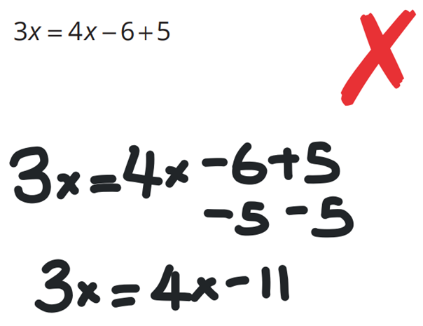  Umi’s work: | What did Umi do wrong in her first step?  Incorrect inverse operation.  Also, you need to subtract from both sides,  not from each constant term.  What should Umi have done on the right side of the equation to solve it?  Simplify – 6 + 5 to – 1, then subtract 3x or 4x from both sides.  Solve:  $$6x=3x-5-4$$  $$x=-3$$
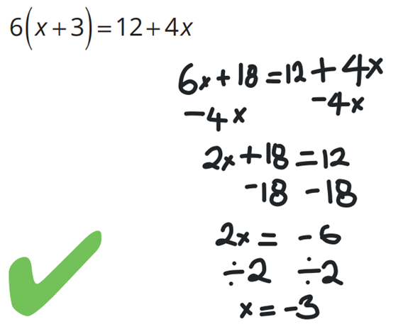  George’s work: | Where did George get $6x+18$ from?  He expanded the brackets  Solve:  $$-3\left(x+6\right)=4-5x$$  $$x=11$$

Mastery
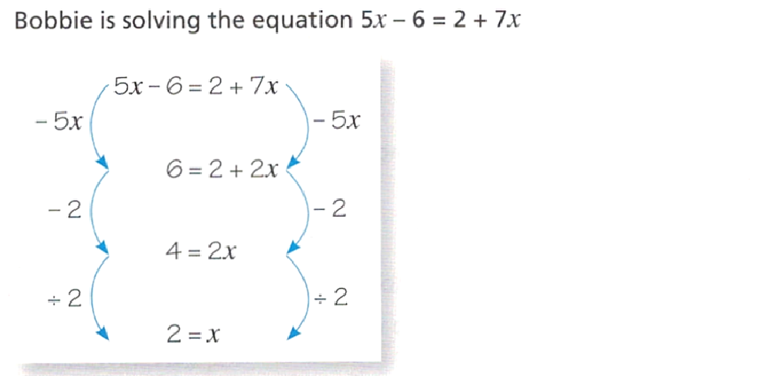

Verify Bobbie’s solution by substitution to show it is incorrect.
LHS $=$ | RHS $=$
LHS = 4 , RHS = 16
$LHS≠RHS$ so 2 is not the solution.
Identify Bobbie’s error and solve the equation correctly.

He should have kept the negative sign with 6 on the left.
$$x=-4$$
- Solve these equations. The answers may be positive or negative integers or fractions,
- $3m+7=8m+2$  $$m=1$$ | - $7t-6=4t+5$  $$t=\frac{11}{3}$$
- $6h-8=2h-7$  $$h=\frac{1}{4}$$ | - $12+3w=6w-4$  $$w=\frac{16}{3}$$
- $5p=2p+8$  $$p=\frac{8}{3}$$ | - $5p=2p-8$  $$p=-\frac{8}{3}$$
- $k-19=6k-3$  $$k=-\frac{16}{5}$$ | - $6t=4t+8-3t$  $$t=\frac{8}{5}$$
- Solve the following equations. Simplify first.
- $5x+7-3=x-10$  $$-\frac{7}{2}$$ | - $8x+6-2x=4x+8$  $$1$$
- $9x+8+2x=3x-16$  $$-3$$ | - $10x+12-2x=6x+8-4x$  $$-\frac{2}{3}$$

Equations with Brackets and Pronumerals on Both Sides

- Solving Problems using Equations
If an equation has brackets and pronumerals on both sides, you should expand the brackets.
- Expand any brackets.
- Simplify, if possible.
- Move $x$ to one side.
- Solve for $x$ by applying inverse operations to both sides.

- Example Solve equations with pronumerals on both sides
$4\left(x+3\right)=7x+15$1. Expand $4x+12=7x+15$3. Move $x$ $-4x -4x$  $12=3x+15$4. Solve $-15 -15$  $-3=3x$  $÷3 ÷3$ $-1=x$ | $5\left(6x+5\right)-12=4x+1$  1. Expand $30x+25-12=4x+1$  2. Simplify $30x+13=4x+1$  3. Move $x$ $-4x -4x$  $26x+13=1$  4. Solve $-13 -13$  $26x=-12$  $÷26 ÷26$ $x=-$ $\frac{6}{13}$

- Guided Practice
- $2\left(2x+3\right)=27-3x$  $4x+6=27-3x$  $x=3$ | - $2\left(4x+5\right)=9x$  $x=10$
- $7x=3(2x-3)$  $$x=-9$$ | - $3\left(x-5\right)=2(x-1)$  $$x=13$$
- $2\left(x+5\right)+3=3x$  $$x=13$$ | - $3\left(5x+2\right)-10x=16$  $$x=2$$

Foundation

  - Consider the equation:
$$5\left(2x+7\right)=40$$
Solve this equation by:
Dividing by 5 first | Expanding first
$$x=\frac{1}{2}$$
  - Consider the equation:
$$6\left(2x+7\right)=40$$
Solve this equation by:
Dividing by 6 first | Expanding first
$$x=-\frac{1}{6}$$
  - Consider the equation:
$$5\left(x+7\right)+6=41$$
Solve this equation by:
Subtracting 6 first | Expanding first
$$x=0$$
  - By considering your answers above, how do you know whether to expand first?

You should expand if dividing would lead to a fraction.
- Solve these equations. For some, it will be easier to expand first.
- $5\left(2x-4\right)=-70$  $$-5$$ | - $3\left(x+1\right)+2=-1$  $$-2$$ | - $-2\left(x+2\right)-4=4$  $$-6$$
- $-8\left(-5+3v\right)=54.4$  $$-\frac{3}{5}$$ | - $-2\left(-9e+7\right)=12.2$  $$\frac{131}{90}$$ | - $3\left(x-1\right)-5=-11$  $$-1$$

Development
- Solve these equations by expanding then simplifying first.
- $2\left(3x-1\right)+4x=12$  $$\frac{7}{5}$$ | - $2\left(3x+1\right)-4x=12$  $$5$$
- $2\left(3x-1\right)-4=12$  $$3$$ | - $2\left(3x-1\right)+4=12$  $$\frac{5}{3}$$
- $18=5+2\left(x-4\right)$  $$\frac{21}{2}$$ | - $4\left(x+6\right)-8=48$  $$8$$
- $-5\left(g+4\right)+9=-41$  $$6$$ | - $-7\left(x+5\right)+4=-17$  $$-2$$
- $6\left(q+1\right)-5=-23$  $$-4$$ | - $-2\left(x+2\right)-4=4$  $$-6$$
- $-8\left(x+4\right)-3=-59$  $$3$$ | - $-2\left(x-2\right)-7=-29$  $$13$$
- $5\left(y+7\right)-2y=42$  $$\frac{7}{3}$$ | - $4k+6\left(3k+1\right)=-38$  $$-2$$
- $9\left(3-n\right)+n=7$  $$\frac{5}{2}$$ | - $2\left(5-m\right)-3m=30$  $$-4$$
- Solve the following equations. Expand any brackets first.
- $4\left(w+3\right)=7w+15$  $$-1$$ | - $2\left(2v+3\right)=27-3v$  $$3$$ | - $2\left(4j+5\right)=9j$  $$10$$
- $7d=-3\left(2d-3\right)$  $$\frac{9}{13}$$ | - $3\left(5x+2\right)=-2\left(5x+8\right)$  $$-\frac{22}{25}$$ | - $3\left(4+2y\right)=2(-4-2y)$  $$-2$$

- Solve the following equations. Expand any brackets and simplify first.
- $5\left(2x+5\right)=2x+13$  $$-\frac{3}{2}$$ | - $6\left(3x+1\right)=4x+20$  $$1$$
- $3x+4=5\left(6x+5\right)+60$  $$-3$$ | - $3x+4=6\left(5x-5\right)+88$  $$-2$$
- $4x-6=-8\left(6x-7\right)+42$  $$2$$ | - $8\left(8x+5\right)=3\left(6x+8\right)+108$  $$2$$
- $5\left(4x-3\right)=3\left(-4x+4\right)+101$  $$4$$ | - $-5\left(-5x+5\right)=7\left(4x-8\right)+37$  $$-2$$
- $7\left(x-8\right)=4\left(3x+5\right)+24$  $$-20$$ | - $5\left(6x+7\right)=25x+2(11-4x)$  $$-1$$

Mastery
- Read the example carefully and answer the questions:
Solve:  $$4-2\left(x+2\right)=8 \\ 4-2x+4=8 \\ 8-2x=8 \\ -2x=0 \\ x=0$$ | By substituting $x=0$ into the original equation, show that this solution is incorrect.  Explain the mistake this student made when expanding, then solve the equation correctly.  They didn’t correctly expand. $-2\left(x+2\right)=-2x-4$

- Solve the following equations:
- $2-3\left(x+1\right)=-1$  $$0$$ | - $5-3\left(x-1\right)=-11$  $$\frac{19}{3}$$ | - $-4-2\left(x+2\right)=4$  $$-6$$

- 2010 HSC Mathematics Standard 2 Band 4
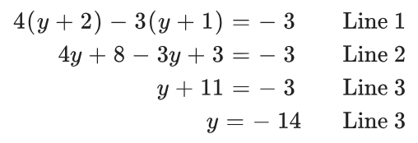
Fred tried to solve this equation and made a mistake in Line 2

Copy the equation in line 1: ………………………………………………………
Rewrite line 2 correcting his mistake: ………………………………………………………
$$4y+8-3y-3=-3$$
Continue your solution to solve for $y$ ………………………………………………………
………………………………………………………
………………………………………………………
$$y=-8$$

Further Problem-Solving using Equations

- Solving Problems using Equations
The problems in this section will involve pronumerals on both sides.
- Let a pronumeral, like $x$, represent the unknown quantity.
- Write an equation describing the scenario.
- Solve the equation.
- Check the answer makes sense and include units.

- Example Solve problems using equations with pronumerals on both sides.
Purchasing five apples and a $2.40 mango costs the same as purchasing seven apples and a mandarin that costs 60 cents. What is the cost of each apple?
1. Let $c=$ cost of an apple.
2. $5c+2.4=7c+0.6$
3. $2.4=2c+0.6$
$1.8=2c$
$0.9=c$
4. An apple costs 90 cents (or $\$0.90$)

- Guided Practice
- Purchasing 7 pencils and a $1 ruler is the same as purchasing 3 pencils and a $3.80 box of markers.  How much does a pencil cost?  1. Let …… be …………………………  2.  3.  4. | - Kathy’s age four years ago is the same as is half of her age now plus five.  Find Kathy’s age now.  1. Let …… be …………………………  2.  3.  4.

Foundation
- At a newsagency, Preeta bought four pens and a $1.50 newspaper, while her husband Levy bought two pens and a $4.90 magazine. To their surprise the cost was the same.
  - Write an equation to describe this, using $p$ for the cost of a pen.

$$4p+1.50=2p+4.90$$
  - Solve the equation to find the cost of a pen.

$$p=\$1.70$$
- Desmond notes that in 4 years’ time his age when doubled will give the number 50.
Desmond’s current age is $d$.
  - Write an expression for Desmond’s age in 4 years’ time and write an expression for double his age in 4 years’ time.

$$d+4, 2(d+4)$$
  - Write an equation to describe the situation described above.

$$2(d + 4) = 50$$
  - Solve the equation to find his current age.

$$d = 21 years$$

- Form an equation to solve the following.
  - Eight years ago, Tiff was half her age now. How old is Tiff now?

$$t-8=\frac{t}{2}$$
$$t=16$$
Tiff is 16.
  - Two years ago, Tiff's father was three times his own age 28 years ago.
How old is Tiffs father now?

$$f-2=3\left(f-28\right)$$
Father is 41

Development
- The following shapes are rectangles. By solving equations, find the value of the pronumerals.
Some of the answers will be fractions.
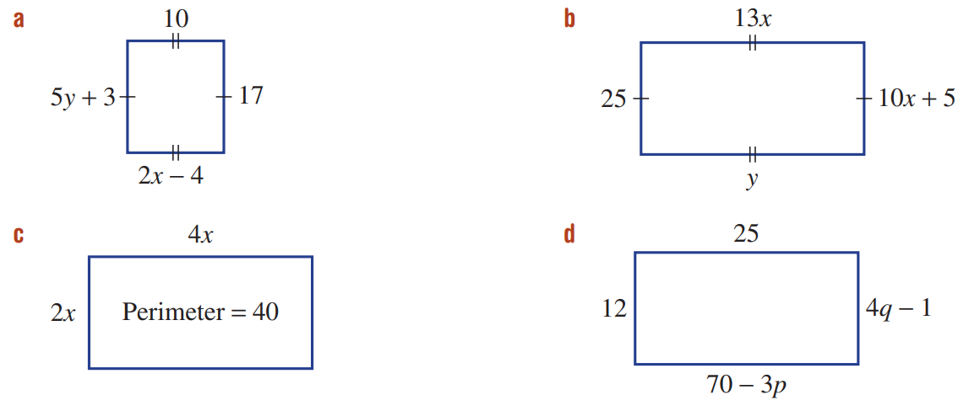  $$x=7, y=\frac{14}{5}$$ | $$x=2, y=26$$ | $$x=\frac{10}{3}$$
$$p=15, q=\frac{13}{4}$$ | 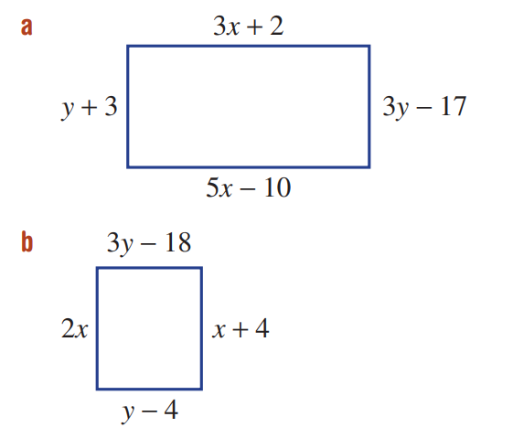  $$x=6, y=10$$ | $$x=4, y=7$$

- Find the values of the pronumerals in the following geometric diagrams.
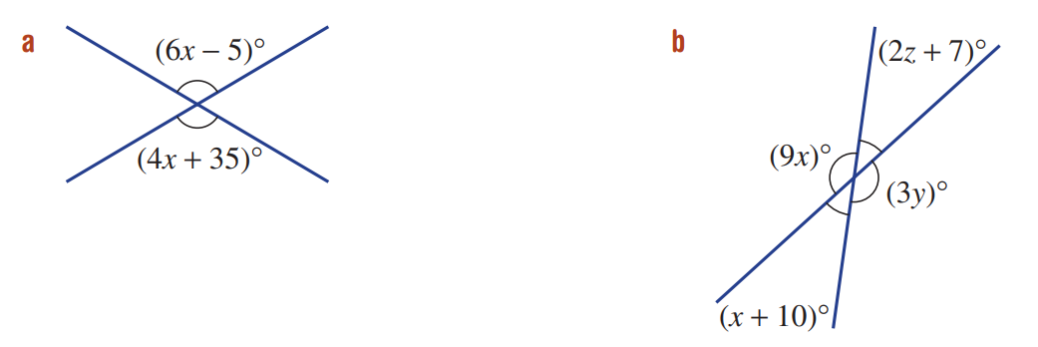  $$x=20$$ | $$x=17, y=51, z=10$$ | 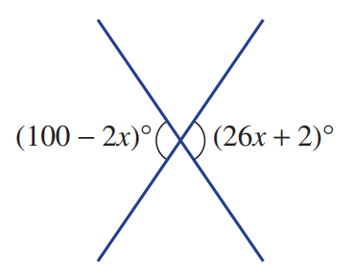  $$x=\frac{7}{2}$$

- I think of a number, double it and add 12. The answer is three times the number I started with. What was my starting number?
Let x = starting number
2x + 12 = 3x
12 = x
Starting number = 12
- I think of a number, double it and add 12. The answer is the number I started with.
What was my starting number?
Let x = starting number
2x + 12 = x
x = -12
Starting number = – 12
- I think of a number, add 12 and then double the result.
The answer is four times the number I started with.
What was my starting number?

Let x = starting number
2(x + 12) = 4x
x = 12
Starting number = 12
- Sally is 58 and Harry is 10 years old. In how many years will Sally be three times Harry’s age?

Let t = years from now
Sally's age in t years: 58 + t
Harry's age in t years: 10 + t
58 + t = 3(10 + t)
t = 14 years

- If you triple the age Rhys was four years ago, you get 27.
Form and solve an equation to find Rhys' age now.

Let x = Rhys' current age
3(x - 4) = 27
x = 13 years old

- If you double the age Ali will be in six years' time, you will get 40. How old is Ali now?

Let x = Ali's current age
2(x + 6) = 40
x = 14 years old
- Kate is three times as old as her son.
If Kate is also 30 years older than her son, what are their ages?
Let $x$ be son’s age
Kate’s age is $3s$ and $s+30$
$$30+x=3x$$
$$x=15$$
Son is 15, Kate is 45

Mastery
- Kristen and Daniel have the same amount of money.
Kristen buys 5 kg of cherries and has $2 left over.
Daniel buys 2 kg of cherries and has $20 left over. What is the cost of 1 kg of cherries?

Let $x$ be 1kg of cherries
$$5x+2=2x+20$$
$$x=6$$
1 kg is $6
- James and Sue have the same amount of money.
James buys seven sushi rolls and has $1.50 left over.
Sue buys four sushi rolls and has $12 left over. Find the cost of a sushi roll.

Let $x$ be 1 sushi
$$7x+1.5=4x+12$$
$$x=3.5$$
1 sushi is $3.50
- Find the unknown number using equations. The answers might not be whole numbers.
- The average of a number and double the number is 25.5.  $$\frac{x+2x}{2}=25.5$$  $$\frac{3x}{2}=25.5$$  $$3x=51$$  $$x=17$$ | - The average of a number and triple the number is 25.5.  $$\frac{x+3x}{2}=25.5$$  $$\frac{4x}{2}=25.5$$  $$2x=25.5$$  $$x=12.75$$
- Adding 3 to twice a number is the same as subtracting 9 from half the number.  $$2x+3=\frac{x}{2}-9$$  $$4x+6=x-18$$  $$3x=-24$$  $$x=-8$$ | - Adding 5 to twice a number is the same as subtracting 9 from half the number.  $$2x+5=\frac{x}{2}-9$$  $$4x+10=x-18$$  $$3x=-28$$  $$x=-\frac{28}{3}$$
- The average of a number and double the number gives the same result as adding 1 to the original number and then multiplying by one-third.
$$\frac{x+2x}{2}=\frac{1}{3}\left(x+1\right)$$
$$\frac{3x}{2}=\frac{x+1}{3}$$
$$9x=2(x+1)$$
$$9x=2x+2$$
$$7x=2$$
$$x=\frac{2}{7}$$
- Abdullah has 4 packets of mints and 7 more mints.
Beca has 2 packets of mints and 31 more mints.
Each packet contains the same number of mints.
If Abdullah and Beca each have the same number of mints, how many mints do they have altogether?
Let $x$ be number of mints in a packet.
4x + 7 = 2x + 31
x = 12
Together they have 6(12)+38=110
- Ed collects 5c and 10c coins in a jar. The jar contains three more 5c coins than 10c coins. Altogether there is $1.80 in the jar.
Form and solve an equation to find the number, $x$, of 10c coins in the jar.
Let x = number of 10c coins
Number of 5c coins = x + 3
5(x + 3) + 10x = 180
x = 11
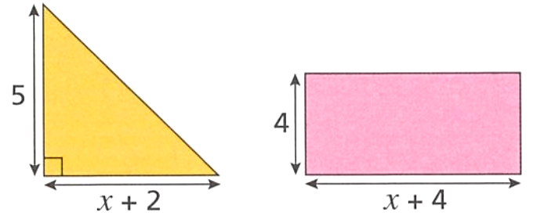
- The area of the rectangle is double the area of the triangle. Find both their areas.
Triangle area = $\left(\frac{1}{2}\right)\left(x + 2\right)\left(5\right)$= $\frac{5x + 10}{2}$
Rectangle area = $4(x + 4)$ = $4x + 16$
Rectangle area = 2 × Triangle area:
$$4x+16=2×\frac{5x+10}{2}$$
$$4x + 16 = 5x + 10$$
$$6 = x$$
Triangle area = 20
Rectangle area = 40
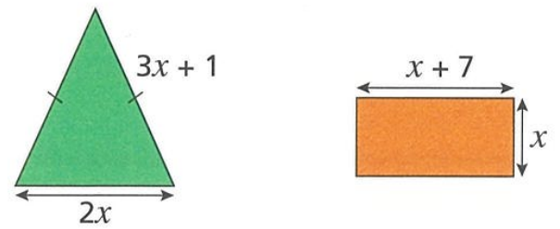
- The perimeter of the triangle is the same as the perimeter of the rectangle.
Work out the area of the rectangle.
Triangle perimeter = 2x + (3x + 1) + (3x + 1) = 8x + 2
Rectangle perimeter = 2(x + 7) + 2x = 4x + 14
Equal perimeters: 8x + 2 = 4x + 14
4x = 12
x = 3
Rectangle area = 3(3 + 7) = 30

- Find the area and the perimeter of this rectangle.
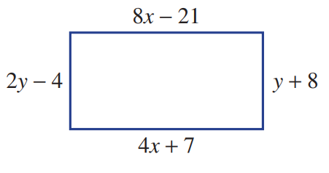
Opposite sides equal in rectangle:
8x - 21 = 4x + 7 and 2y - 4 = y + 8
x = 7,
y = 12
Length = 8(7) - 21 = 35
Width = 12 + 8 = 20
Area = 35 × 20 = 700
Perimeter = 2(35 + 20) = 110
- Show that the rectangular shape shown must be a square.
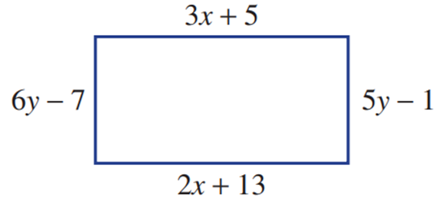
Opposite sides equal in rectangle:
3x + 5 = 2x + 13 and 6y - 7 = 5y - 1
x = 8 and y = 6
By substituting and evaluating each side, each side is 29.
A rectangle with all sides equal is a square.

- A man is currently three times as old as his son.
In 11 years from now he will be twice as old as his son will be then.
How old is his son now?
Let s = son's current age
Man's current age = 3s
In 11 years: (3s + 11) = 2(s + 11)
s = 11
Son is 11 years old now
- At present Jen is 8 years older than Wesley.
In 3 years from now, Jen’s age will be double Wesley’s age.
How old is Wesley?
Let w = Wesley's current age
Jen's current age = w + 8
In 3 years: (w + 8 + 3) = 2(w + 3)
5 = w
Wesley is 5 years old
- The sum of Kelly and Sam’s ages is 45 years.
If Kelly’s age was doubled, it would be 5 years more than three times Sam’s age.
How old is Sam?
Let s = Sam's age, k = Kelly's age
k + s = 45
2k = 3s + 5
use k = 45 - s
Substitute: 2(45 - s) = 3s + 5
s = 17
Sam is 17 years old
- Flo has two cats, Misty and Smokey. Misty is twice as old as Smokey.
In four years' time, the sum of their ages will be 17. How old is Misty now?
Let s = Smokey's current age, m = Misty's current age
m = 2s
(m + 4) + (s + 4) = 17
2s + s + 8 = 17
s = 3
m = 6
Misty is 6 years old

- Zach has two dogs, Autumn and Titch. Four years ago, Autumn was three times as old as Titch. The sum of their ages now is 12. What will be the sum of their ages next year?
Let a = Autumn's current age, t = Titch's current age
a + t = 12
(a - 4) = 3(t - 4)
Use a = 12 – t
12 – t – 4 = 3t – 12
t = 5, a = 7
Next year their ages will sum to 14

- Rectangles A and B have the same area.
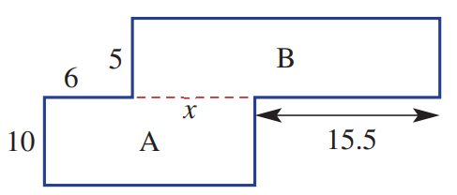
  - What is the value of $x$?

$$10\left(6+x\right)=5\left(15.5+x\right)$$
$$x=3.5$$

  - State the perimeter of the shape.
80

